Student Management System

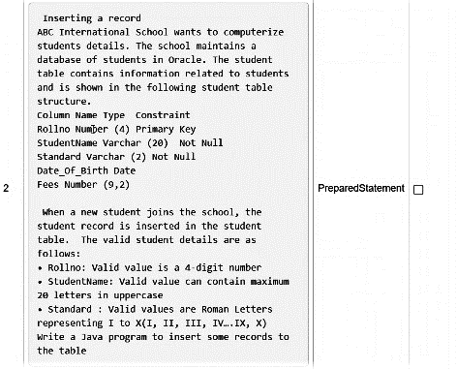

SQL Command:

create table NewStudents

(Rollno Number(4) Primary Key,

StudentName varchar (20) not null,

Standard varchar (2) not null,

Date_of_Birth Date,

Fees Number (9,2)

);

Java File:

import java.sql.*;

import java.util.*;

public class Main {

public static int counts(int n) {

int count = 0;

while (n != 0){

n = n / 10;

++count;

}

return count;

}

public static String integerToRoman(int num) {

int[] values = {1000,900,500,400,100,90,50,40,10,9,5,4,1};

String[] romanLiterals = {"M","CM","D","CD","C","XC","L","XL","X","IX","V","IV","I"};

StringBuilder roman = new StringBuilder();

for(int i=0;i<values.length;i++) {

while(num >= values[i]) {

num -= values[i];

roman.append(romanLiterals[i]);

}

}

return roman.toString();

}

public static void main(String [] args) {

int roll, class1; String std;

Scanner sc = new Scanner(System.***in***);

Scanner sc1 = new Scanner(System.***in***);

System.***out***.println("Enter Student name: ");

String name = sc.nextLine();

name = name.toUpperCase();

if(name.length()>20)

name = name.substring(0,20);

do {

System.***out***.println("Enter Student RollNo.: ");

roll = sc1.nextInt();

}while(*counts*(roll) != 4);

System.***out***.println("Enter Student Standard: ");

class1 = sc1.nextInt();

std = *integerToRoman*(class1);

System.***out***.println("Enter Student Date of Birth: ");

String dob = sc.nextLine();

System.***out***.println("Enter Student fees: ");

Integer fees = sc1.nextInt();

sc.close();

sc1.close();

try {

String url="jdbc:oracle:thin:password/TARPAN@localhost:1521:XE";

String u = "TARPAN";

String p = "password";

String query1 = "insert into NewStudents(Rollno,StudentName,Standard,Date_of_Birth,Fees) values (?,?,?,?,?)";

String driver="oracle.jdbc.OracleDriver";

Class.*forName*(driver);

Connection con=DriverManager.*getConnection*(url,u,p);

PreparedStatement st = con.prepareStatement(query1);

st.setInt(1,roll);

st.setString(2,name);

st.setString(3, std);

st.setString(4, dob);

st.setInt(5, fees);

st.executeQuery();

st.close();

con.close();

}catch(Exception e) {

e.printStackTrace();

}

}

}